**Log 10 - Migration to HELTEC ESP32 Board with OLED Display**

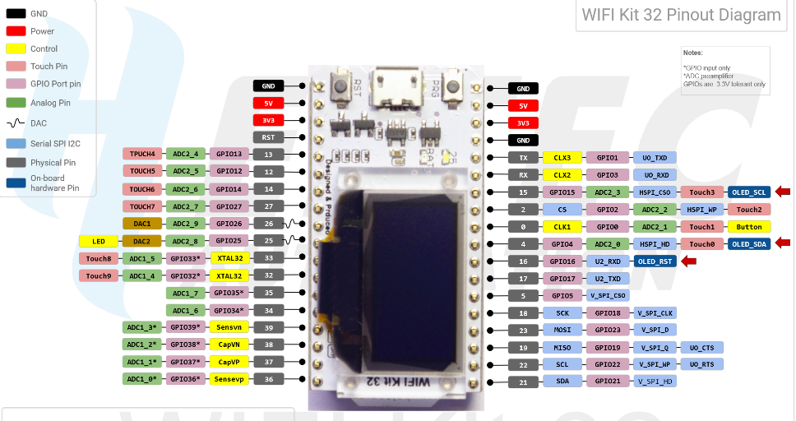

**Issue:**

Accelerometer couldn’t be found on the new MCU.

**Solution:**

While moving to the new eval board the schematic pinout didn’t match the previous one and I accidentally ended up driving 5V to the external pull-up resistor into SDA/SCL. The pins were damage.

In order to resolve the issue, I re-assigned temporarily the global I2C pint to SDA 19 and SCL 23 in adxl357.cpp this was a hard fix for the moment but will solved when OLED is implemented.

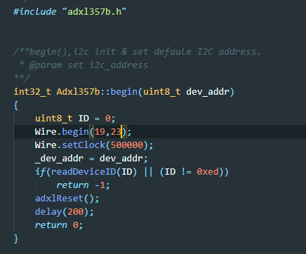

The OLED uses the SDA pin 4 and SCL pin 15 and when initialized overwrites Wire.h next step will be test integration with OLED sharing the same I2C bus.

**References**

<https://github.com/Heltec-Aaron-Lee/WiFi_Kit_series/issues/62>

<https://github.com/Heltec-Aaron-Lee/WiFi_Kit_series/blob/master/PinoutDiagram/WIFI%20Kit%2032.pdf>

https://heltec.org/project/wifi-kit-32/